

Name : Adil Khan
Roll No : 2330-0030
Dept: BS AI
Subject: Data Base system

QUESTION NO 1:

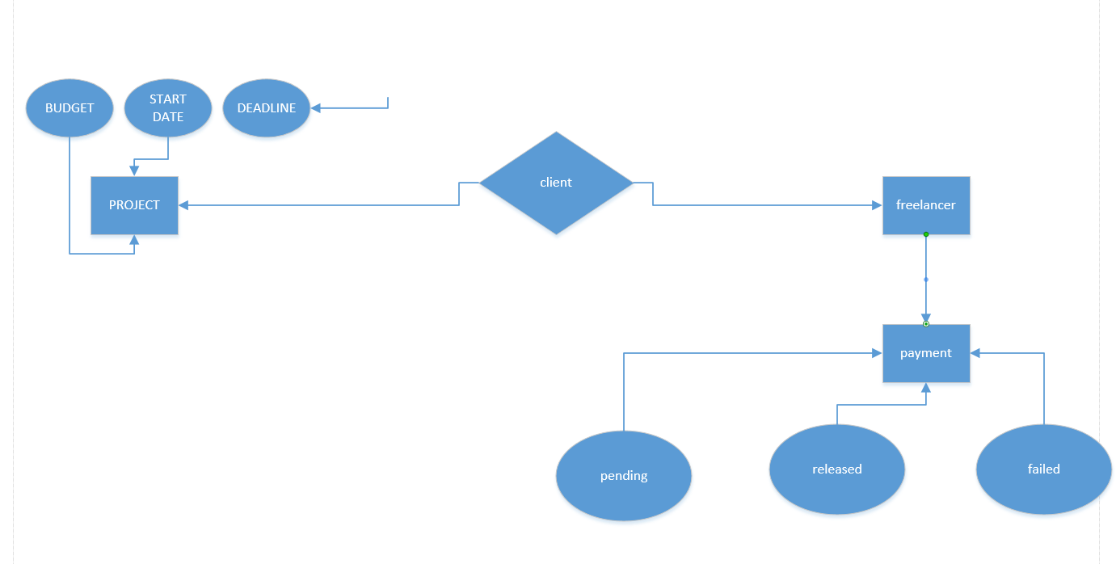

QUESTION NO 2:
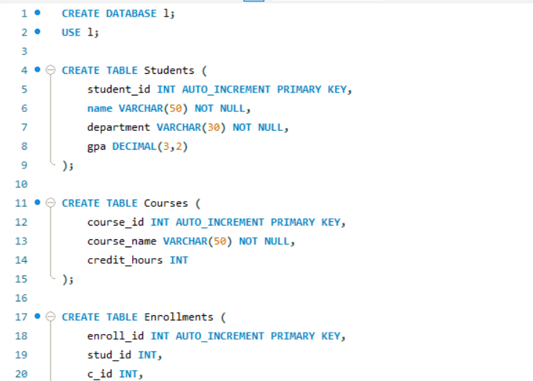

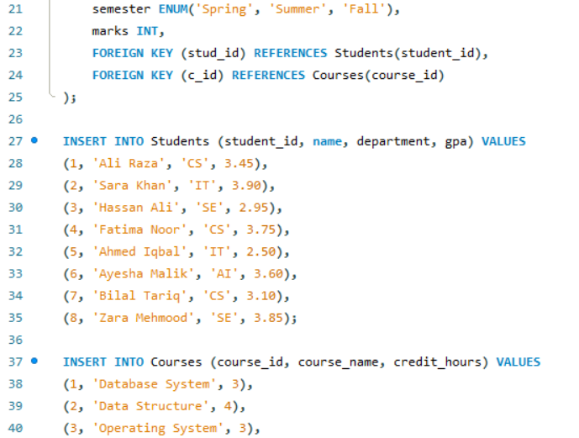

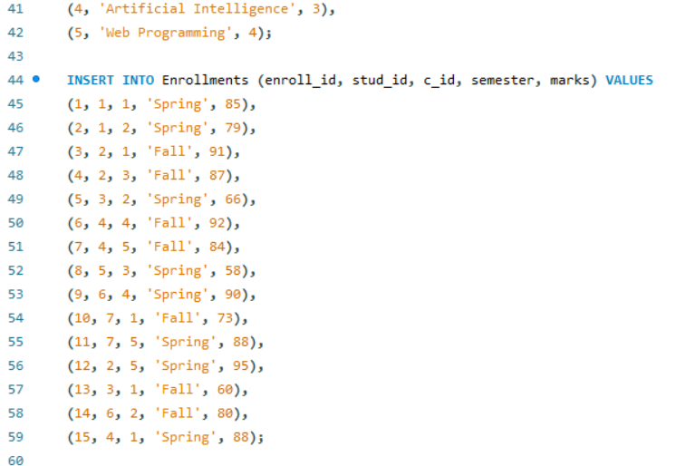

TASK NO 1:
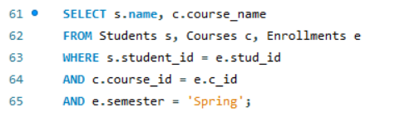
OUTPUT:
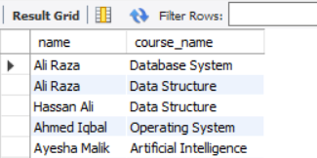
TASK NO 2:
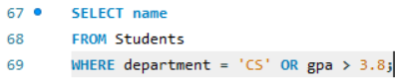
OUTPUT;
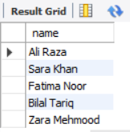
TASK NO 3:
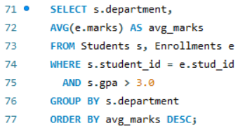
OUTPUT:
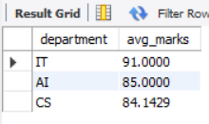
TASK NO 4:
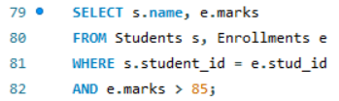
OUTPUT:
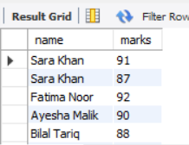
TASK NO 5:

OUTPUT:
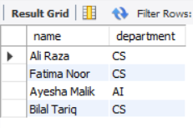
TASK NO 6:
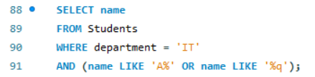
OUTPUT:
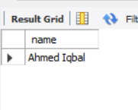
TASK NO 7:
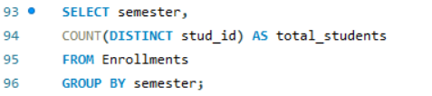
OUTPUT:
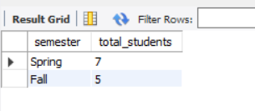
TASK NO 8:
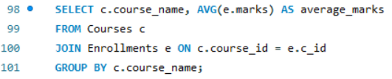
OUTPUT:
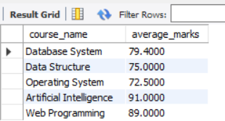
TASK NO 9:
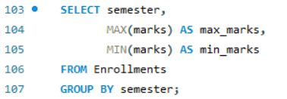
OUTPUT:
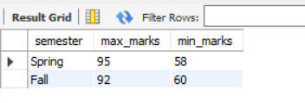
TASK NO 10:

OUTPUT:
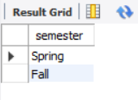

QUESTION NO 3:

TASK NO 1:
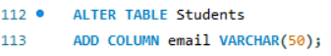
TASK NO 2:

TASK NO 3:
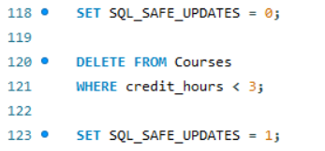
RESULTS:
